Lab 01: Post-Deployment Configuration

Power Portal Configuration

As part of the MVM deployment, Registration and booking portal is deployed however there are some post-deployment steps that needs to be done before using the portal. This exercise details those post-deployment steps.

**Task 1: Update Bing API Key and Map settings**

The appointment scheduling portal lets you search for appointment locations using Bing maps. You must update the portal settings to use your Bing map keys so that users can use this feature in Registration and booking portal. You can also update the default latitude and longitude settings (currently set to the Seattle region) to ensure that the default region of the map is shown appropriately when the maps are displayed for the first time to the users.

In this task, you will learn how to update the Bing API key and other default map settings.

1. Create a [Bing Maps account](https://docs.microsoft.com/en-us/bingmaps/getting-started/bing-maps-dev-center-help/creating-a-bing-maps-account) and [generate an API key](https://docs.microsoft.com/en-us/bingmaps/getting-started/bing-maps-dev-center-help/getting-a-bing-maps-key). *[Note: If you are in an official training then this step is just informational, and no action is required from you because the Bing Map account would have already been set up and the API key would have been provided to you by your instructor.]*
2. Navigate to [Power Apps](https://make.powerapps.com/).
3. Select **Apps** on the left navigation bar and then you can view the list of solutions deployed in the environment.

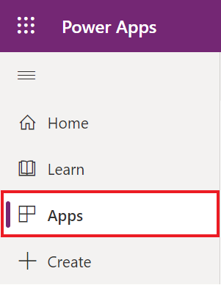

1. Find the **Portal Management** Appand click on it to open it. This app consists of all the Portal settings and its metadata.

1. In the left pane, click on **Site Settings.**

1. On the column **Name,** search for names that begins with "Vaccination Management/Map".

1. Select each of the following records and click on edit to update the values as per the below instructions.
2. **Vaccination Management/Map/Credentials**: Set the Bing API key provided by your lab instructor.
3. **Vaccination Management/Map/DefaultLatitude**: Set the default latitude that the map needs to display on load. For Ex: 47.6740 for Redmond.
4. **Vaccination Management/Map/DefaultLongitude**: Set the default longitude that the map needs to display on load. For Ex: -122.1215 for Redmond.
5. **Vaccination Management/Map/DefaultZoom**: Set the default zoom level which can provide you the desired resolution when the map is loaded. More details on the pixel and zoom level mapping can be found in [Map Control: Zoom Levels -> Resolution | Maps Blog (bing.com)](https://blogs.bing.com/maps/2006/02/25/map-control-zoom-levels-gt-resolution) .Application

   Description automatically generated

**Task 2: Update Portal Binding**

By default, the portal points to the Starter Portal configuration which is the default template for a blank portal. After deploying the solution, you must change the binding of the portal to point to the new portal configuration instead of the starter portal.

In this task, you will learn how to update the portal binding after the solution deployment.

1. Navigate to [Power Apps](https://make.powerapps.com/).
2. Select **Apps** on the left navigation bar and then you can view the list of solutions deployed in the environment.



1. Find the **Registration and booking portal***. [Note: The portal name might be different in your environment but there is only one Portal App and is the one that needs to be selected.].* This is the portal used for Registration and booking appointments.

1. Select **More Commands (…)** > **Browse**. This will open the **Registration and booking** **portal**. You may also select the app name or click Browse on the top command bar to open it.

1. **You should see the Starter Portal template in the Registration and booking portal.**

1. **Close the Registration and booking portal website. Now you will configure it to the Vaccination Management Registration Portal template.**
2. **Return to the Power Apps screen in the Apps section.**
3. Select the **Registration and booking portal** app if it isn’t already selected.
4. Select **More Commands (…)** > **Settings**. This will pop out the **Portal settings** panel on the right.

1. In the right pane, select **Administration** to open Power Apps Portals Admin Center in a new tab page.

1. This will open a new tab, the **Power Apps Portals admin center,** where you can do portal administrative tasks.
2. The page should open in the **Portal Details** tab of the Power Apps Portals admin center**.**
3. Scroll down to **Update Portal Binding >** **Select** **Website Record,** Open the **Select Website Record** drop down and change the current value (**Starter Portal**) to **Vaccination Management Registration Portal** and then click on **Update button.** This will bind the **Vaccination Management Registration Portal** template with this portal URL and show the proper user interface to the user.

1. In left pane, Select **Portal Actions** and then click **Restart** to restart the portal for the changes to take effect.

1. When prompted, confirm the **Restart** for the portal.

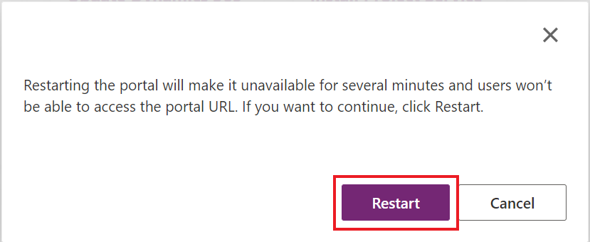

1. Wait 1-5 minutes for the portal to restart. (Feel free to refill your water or stretch those legs!)
   1. You may also jump ahead to the next exercise, as we will open the portal later in the next exercise.
2. Navigate back to the Registration and booking portal.
   1. Navigate to the [Power Apps](https://make.powerapps.com/) (https://make.powerapps.com/).
   2. Select **Apps** > **Registration and booking Portal** app.
   3. Open the app by selecting the app name or clicking Browse.

1. If you see the following error, the portal is still restarting.

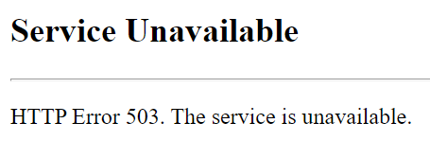

1. Once the Portal is opened and running properly, it should look like the following image. Also, **copy and store the portal URL** (without ‘https://’) as you will be using it to update the environment variable in the next exercise.

**Task 3: Enable Virtual Waiting Room**

Virtual waiting room feature in MVM Registration and booking portal:

* Allows to streamline demand during burst load situations.
* Takes out the unpredictability element.
* Provides a predictable user experience which users expect from a consumer grade site.

Enabling this feature will limit the number of people allowed on the site through a virtual queue mechanism. When queue is full, new users are placed in waiting room and provided with a default page which is configurable. Every minute more users are automatically allowed into the site depending on the queue length configuration.

As part of this task, you will learn the steps to enable virtual waiting room and its parameters. In an actual customer implementation, contact Product Group before setting up any of these parameters so that based on the expected volumes, if necessary, product group can scale the portal and provide the expected parameter values.

1. Navigate to [Power Apps](https://make.powerapps.com/).
2. Select **Apps** on the left navigation bar and then you can view the list of solutions deployed in the environment.

1. Find the **Portal Management** App and click on it to open it. This app consists of all the Portal settings and its metadata.

1. In the left pane, click on **Settings.**

1. Select each of the following records and click on edit to update the values as per the below instructions.
2. On the record ending with **EnableThrottling:** To enable the virtual waiting room feature, set the value as **true.**
3. On the record ending with **ThrottlingCounterThreshold:** The value in this field indicates the number of users to be allowed within a specified time. In this task, to experience the waiting room feature, set the value to 1 which means only 1 session is allowed per minute and other sessions are expected to be in the virtual waiting room. However, in an actual customer implementation, contact Product Group before setting up this parameter so that based on the expected volumes, if necessary, product group can scale the portal and suggest the expected value.
4. On the record ending with **ThrottlingTimeout:** The value in this field indicates the time limit within which the max. number of users are to be allowed. In this task, to experience the waiting room feature, set the value to 00:01:00 which means that 1 session is allowed per minute.

1. Navigate back to the Registration and booking portal.
2. Navigate to the [Power Apps](https://make.powerapps.com/) (https://make.powerapps.com/).
3. Select **Apps** > **Registration and booking Portal** app.
4. Open the app by selecting the app name or clicking Browse.

1. It should look like the following image.

1. Immediately copy and paste the portal URL into a different browser and you would see the virtual waiting room page. If you are bit late then try to open the portal in different tab pages and you will notice the difference.

1. Wait for a minute on the same page and you will then see the actual homepage of the registration portal.

1. Navigate back to the Portal Management Settings Page
   1. Find the **Portal Management** App and click on it to open it. This app consists of all the Portal settings and its metadata.

* 1. In the left pane, click on **Settings.**

* 1. Disable the virtual waiting room feature by update the value to **false** on the record ending with **EnableThrottling.**

**Congratulations!** You completed the post deployment steps to configure the Registration and booking Portal. After updating the bindings and restarting the portal, the website should now show as Vaccination Management Registration Portal template rather than Starter Portal. You have also learned the steps to enable the virtual waiting room feature.